**SQL MURDER MYSTERY**

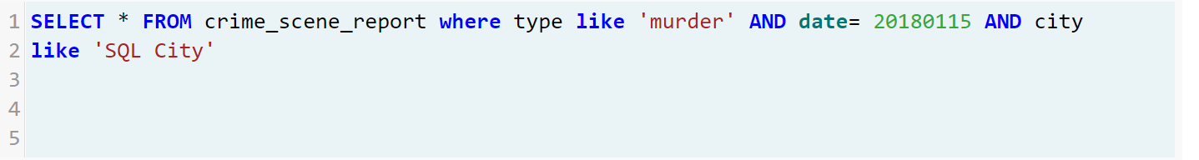

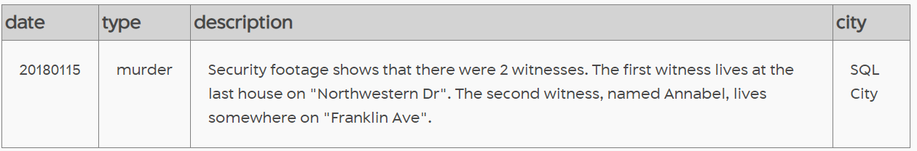

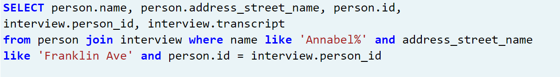

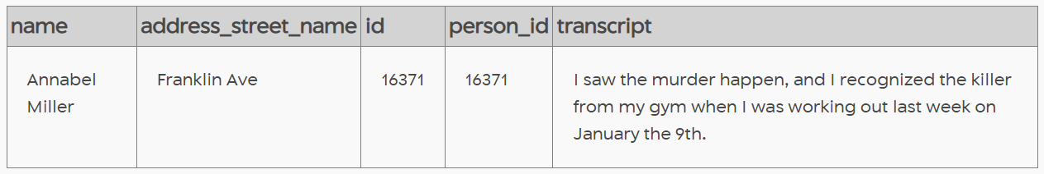



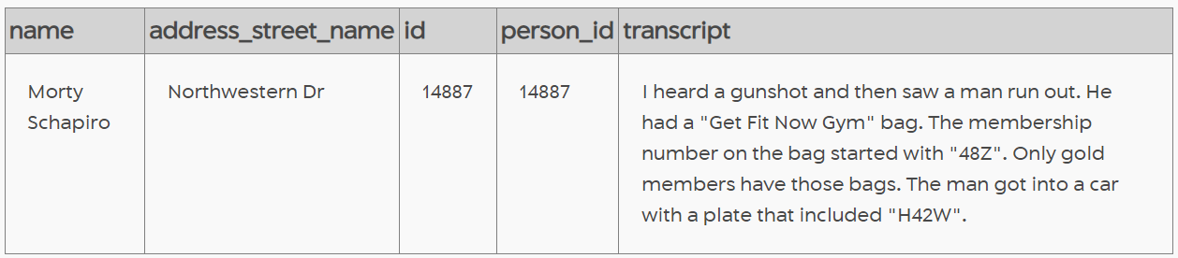

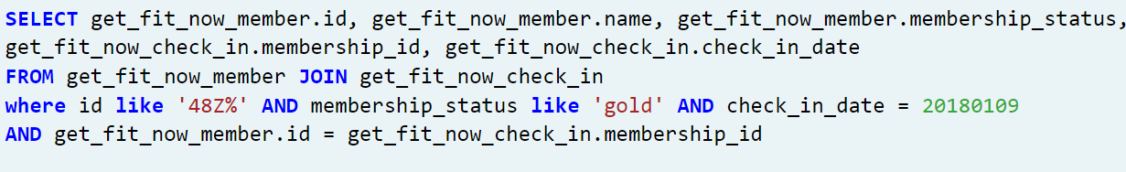

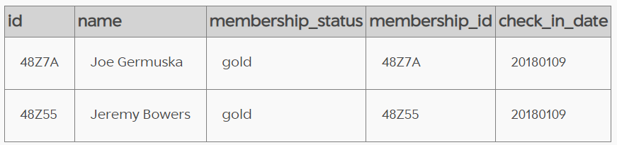



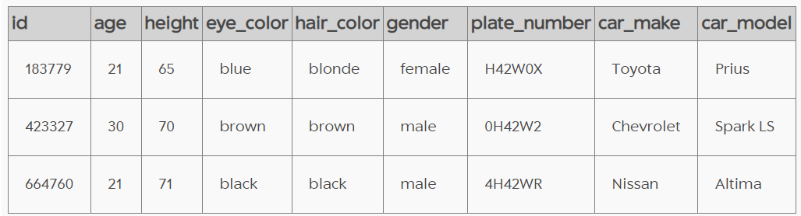



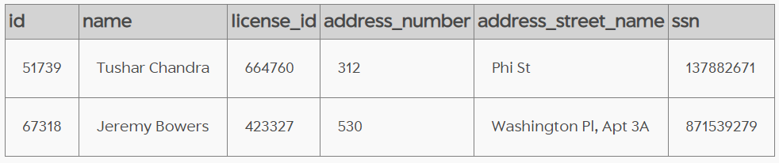





Since Tushar doesn’t have a Gym membership and, according to the witness, the murderer had a gym membership, Tushar is not the murderer. Hence the one left is Jeremy Bowers, who is the murderer.

SUBMITTED BY,

2237026 ( ANNA ANTONY)